Site Map

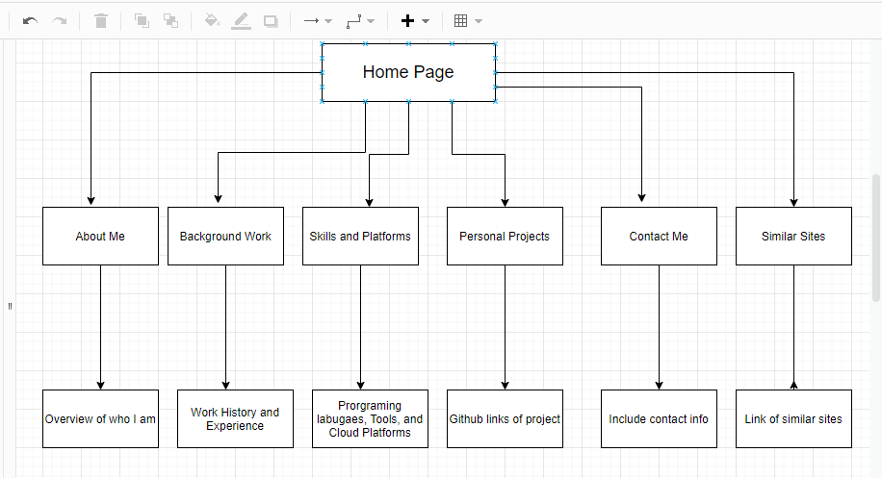

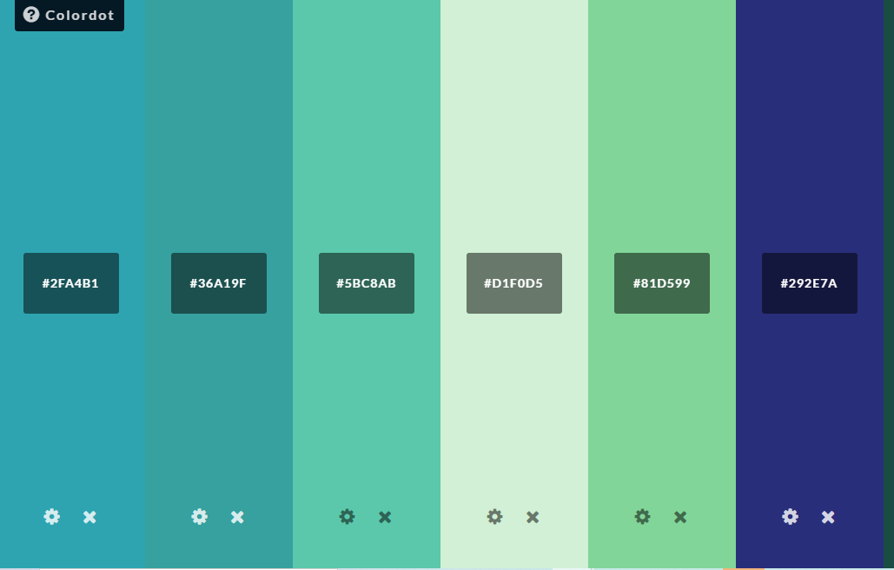

Color Scheme of website and the corresponding colors with the corresponding page below

Homepage- #2FA4B1 text fields for Homepage - ##D1F0DS

Contact Me- #36A19F text fields Contact me - ##D1F0DS

BackgroudWork-#58C8AB text fields for BackgroundWork- ##D1F0DS

Skills and Platforms-#D1F0DS text fields for Skills and Platforms- #2FA4B1

About Me-#292E7A text fields for About Me - ##D1F0DS

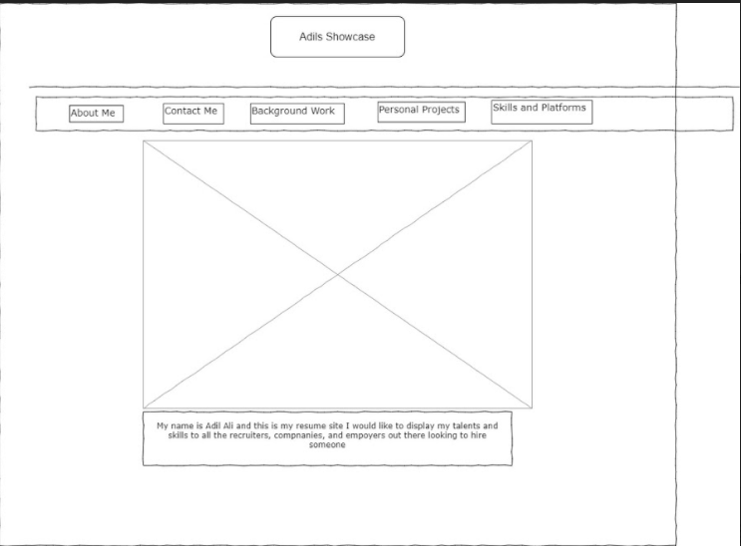

Homepage

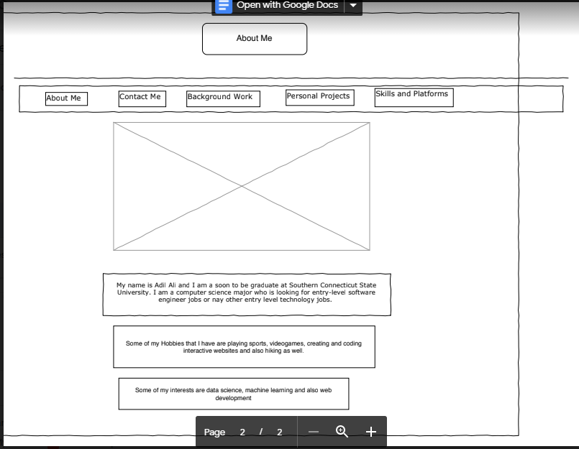

About Me

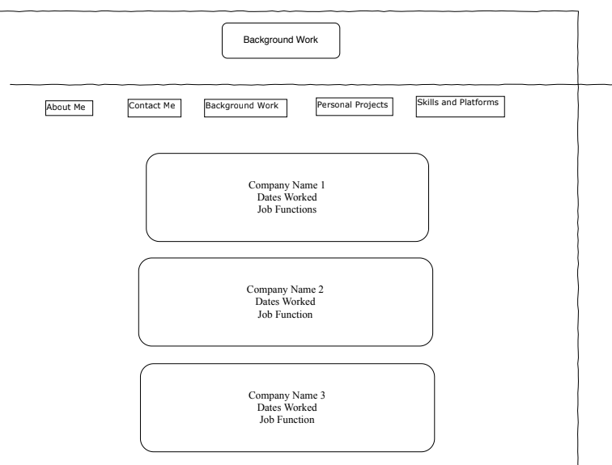

Background Work

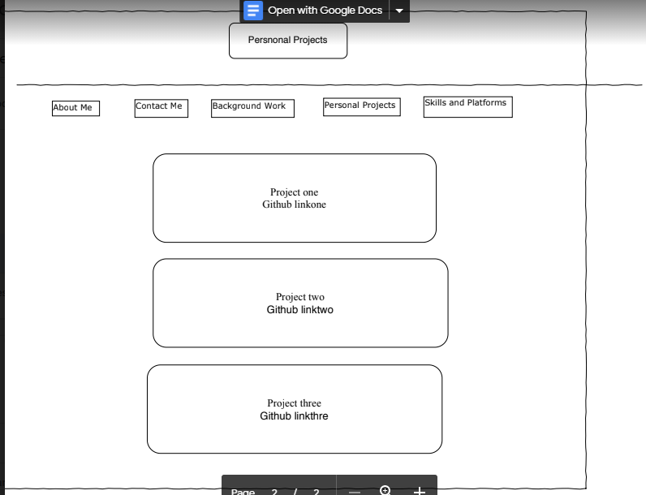

Personal Projects

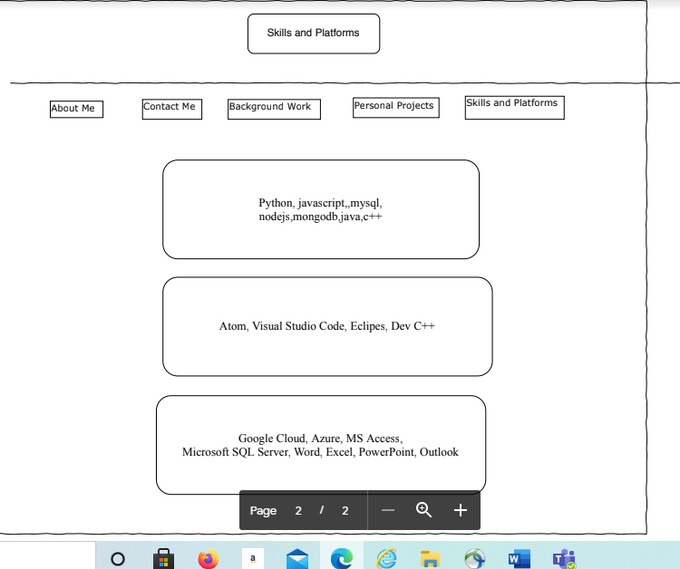

Skills and Platforms

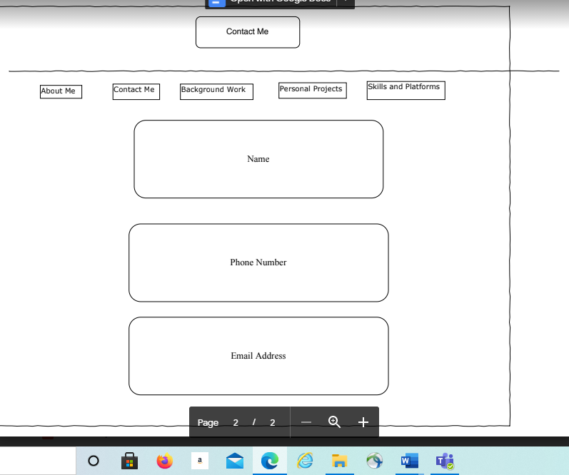

Contact Info